**2019鄭芝龍國際學術研討會**

**鄭芝龍的海洋時代**

**International conference on Yquwn studies**

**SEA POWER OF YQUEN**

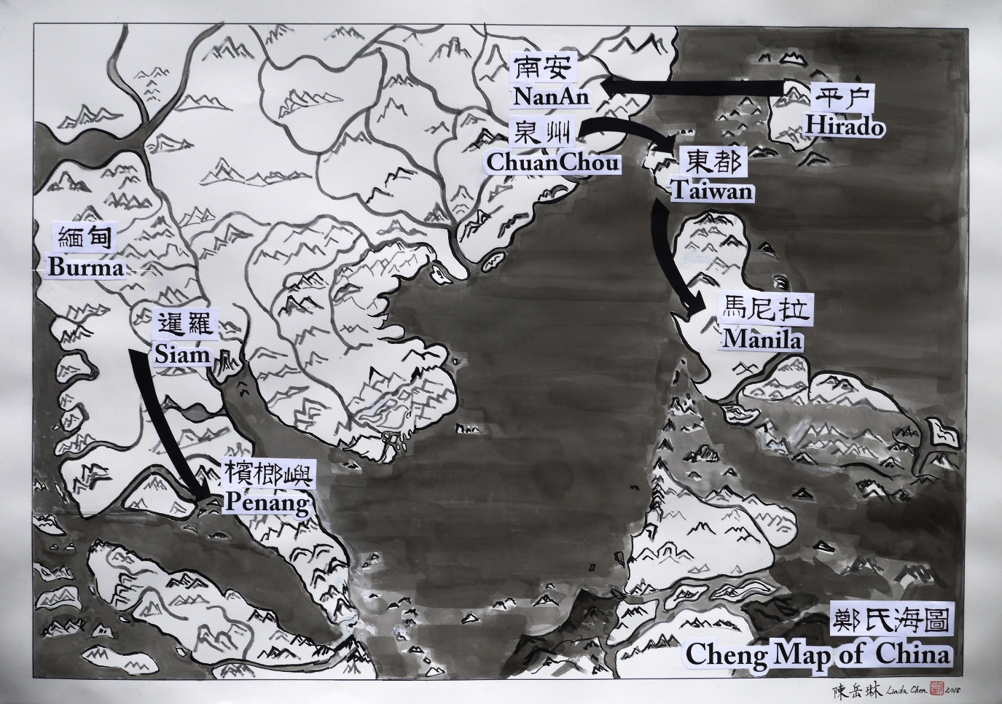

**April 26-27, 2019**

**Tamkang University Chueh-sheng International Conference Hall (10th Fl.)**

**April 26, 2019(Friday)**

**Tamkang University Chueh-sheng International Conference Hall (10th Fl.)(淡江大學覺生國際會議中心)**

9:30-9:40 Opening Session

**鄭宏銘、鄭俊達**

9:40-10:00 **Group photography & Coffee Break**

10:00-10:50 Keynote Speech

Chair & Discussant:**周宗賢**( Tamkang University)

**陳國棟**(Institute of History and Philology, Academia Sinica)

10:50-11:00 **Coffee Break**

11:00-11:50 Keynote Speech

Chair & Discussant:

**Patrizia CARIOTI**(University of Napoli)*Zheng Zhilong's*

*International*

Role in Maritime East Asia: Some Considerations and Remarks

**11:50-13:00 Lunch**

**13:00-15:00** Chair & Discussant

**Paola CALANCA** (EFEO), *Family survival strategy during the Zheng*

*regime and Ming-Qing dynastic transition conflicts*

**翁佳音**(Institute of Taiwan History, Academia Sinica)

**Emmanuel JOURDA**()*The broker who would be king*

**李毓中**(National Tsing Hua University) 西班牙文獻中的鄭芝龍

15:00-15:20  **Coffee Break**

15:20-17:20 Chair & Discussant

**陳國棟**(Institute of History and Philology, Academia Sinica)

**李廣超**(Guangxi University of Finance and Economics) 論石井鄭氏家

族與鄭芝龍早期海洋活動探析

**盧正恒**(Emory University) 與國休戚：鄭芝龍在北京的生活、黨

爭、流放與死亡

**Xing Hang**(Brandeis University) 鄭氏對於十七世紀後半期華人在東

南亞的移民和開發的巨大影響

17:20-17:30 Closing ceremony

18:00  **Dinner**